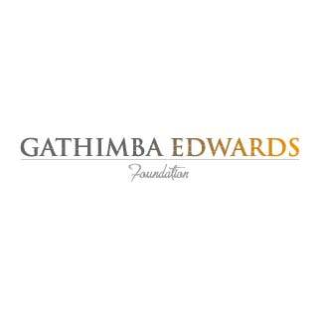
I’m taking part in
GEF’S JOURNEY TO SCHOOL throughout August to help raise school supplies for children in Kenya
Sponsored by

